Prince George’s Baptist Association
Membership Application Form

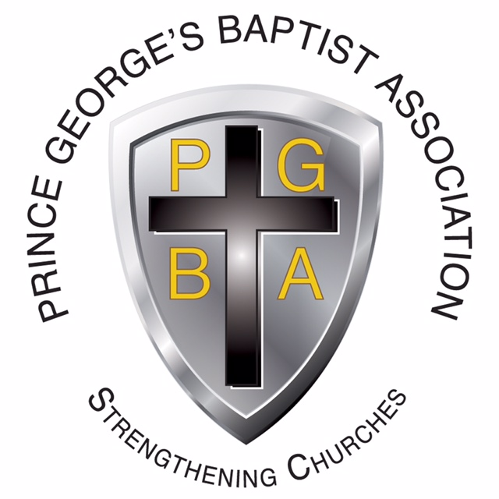

Dr. Greg Kame
Interim Director of Missions
6318 Princess Garden Parkway
Lanham, Maryland 20706
240-764-7503

IMPORTANT INFORMATION

- A church must be a Baptist Church who believes in New Testament principles.

- A church must be willing to support the Southern Baptist denomination causes. This includes the local Prince George’s Baptist Association, the Baptist Convention of Maryland/Delaware and the Southern Baptist Convention.

- Submit in writing the following:
  - A written request for membership (application provided)
  - Theological Statement (copy)
  - Your church constitution (a copy)

- Each October and in the spring, the Prince George’s Baptist Association meets for business and inspiration. The church needs to send messengers to the meetings.

- Two messengers for the first 20 members
- One additional messenger for every 40 members
- No church shall have more than 15 messengers

- The pastor and one lay person will also serve on the Executive Committee.

- While a church becomes a part of an Association by formal vote, it becomes a part of the Baptist Convention of Maryland/Delaware and the Southern Baptist Convention by making monetary contribution.

The associational staff welcomes any opportunity to discuss with any group the benefits of a church participating in the Association and other Baptist bodies.

WHAT IS EXPECTED FINANCIALLY FROM EACH MEMBER CHURCH

Each church is expected to support monthly the mission programs of the Southern Baptist Convention.

A CHURCH SUPPORTS MISSIONS IN TWO WAYS:

- By giving monthly to the Prince George’s Baptist Association. This takes care of mission work in Prince George’s County.
- Strengthening churches for missions
- Christian Social Ministries
- Training Leadership in local churches
- Ministry to Youth
- Pastoral Counseling Center
- Work of the Director of Missions

Each member church is encouraged to give 4% of their monthly budget to the Prince George’s Baptist Association. A check should be mailed each month to the Associational office at 6318 Princess Garden Parkway, Lanham, Maryland 20706.

- By giving monthly to World Missions. This is called giving through the Cooperative Program. This supports all mission work in the State of Maryland, the U.S.A. and all our Foreign Mission areas. Each church is encouraged to give 6% to 10% of their monthly budget to the Cooperative Program. A monthly check should be mailed to the Maryland State Baptist office at 10255 Old Columbia Road, Columbia, Maryland 21046.

NOTE: One can easily see that Southern Baptists mean business when it comes to missions. We believe it’s better to give than to receive. We believe in the stewardship of tithing. We believe a church should tithe its income to missions just as we ask individuals to tithe to the church. The church should be the example and be a model to its people.

All of these missionaries and programs are operating today because 35,000 churches believe in sharing the gospel to every person in the world on a cooperative basis.

WHAT IS EXPECTED IN PARTICIPATION FROM EACH MEMBER CHURCH

The denominational agencies offer a multitude of services to each local church. Each church is encouraged to actively pursue those programs that benefit their church. On the associational level, we attempt to tailor programs to fit each local church.

Application for Membership in
Prince George’s Baptist Association
Date:___________________________
Church Name:___________________________________________________________________

Church Address:_________________________________________________________________

Church Phone #:_______________________________Present Membership:_________________

Church email address:____________________________________________________________

Church Meeting Times:____________________________________________________________

Date of Constitution:_________________________________Federal ID #:___________________

Present Convention\Associations\Afflilitations:__________________________________________

Pastor’s Name:__________________________________________________________________

Wife’s Name:____________________________________________________________________

Pastor’s Address:________________________________________________________________

Pastor’s Home Phone:________________________Pastor’s Cell Phone:____________________

Pastor’s email address:____________________________________________________________
Please state reasons for desiring member in the Prince George’s Baptist Association (use back if needed).
______________________________________________________________________________

______________________________________________________________________________

______________________________________________________________________________

______________________________________________________________________________

______________________________________________________________________________

______________________________________________________________________________

______________________________________________________________________________

Signed by:________________________________________

PLEASE SUBMIT: 1. Theological Statement with application . Copy of Church Constitution and By-Laws

