“MEN GATHERED TO REPAIR THE BREACH” Men’s Retreat

First Rock Baptist Church 2018 Men’s Retreat Registration Form
September 6-8, 2018
Covenant Village Retreat, Clearville, Pennsylvania

Complete this form and submit with your check or money order made payable to FRBC. Please mail to: FRBC ▪ ATTN: 2018 Men’s Retreat ▪ 4630 Alabama Avenue, SE ▪ Washington, DC 20019.

Please mark which method you prefer to receive mailings/info: □ U.S. mail □ email □ text
Please Print Legibly

Name: __________________________________________________ Cell Phone: _____________________________

Address: ________________________________________________________________________________________

City: ______________________________________________________ Zip: _________________________________

Email: _____________________________________________________ Home Phone: __________________________

Your church’s name: __________________________________________ Church’s City:_________________________

Registration fee: $150

Registration fees are NOT refundable-NO EXCEPTION, but are transferable; fees include room, meals, transportation, & materials.

NOTE: Bunk style housing and you must bring your own bedding and toiletries, i.e., pillow, sheets, towel, wash cloth, soap

Payment: (Make check payable to FRBC; in memo section write Men’s Retreat)

For more information contact:
Trustee Frank Nix • 202-253-0237 •• Brother Larry Murdock • 202-276-4297

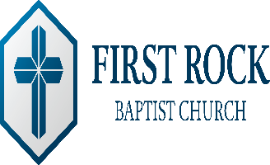
First Rock Baptist Church
Min. Anthony L. Minter, Pastor
4630 Alabama Avenue, SE • Washington, DC 20019
(202) 583-3200 • firstrockbaptistchurch@verizon.net
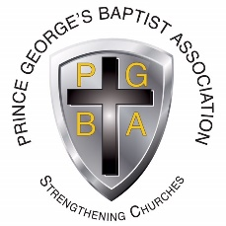
In conjunction with the
Prince George’s Baptist Association
6318 Princess Garden Parkway • Lanham, Maryland 20706
(240) 764-7503 • pgba1968@comcast.net

